CHILD TREATMENT DECLARATION (Rev. 1.0)

Name(s) of Child(ren) | Age | Date(s) of Birth

Name of biological (or adoptive) parent: Relationship:
Name of biological (or adoptive) parent: Relationship:
Name(s) of any other significant caregiver(s): Relationship:
Check the description(s) below that best describe your family. Check more than one if necessary.
In tact family, original family.
In tact blended family with children from previous relationships.
Separating, separated, or divorced.
Separated but both parents still living in same residence with the children.
Separated or divorced and parents are living in separate residences.
A parenting agreement exists, either formally or informally by mutual understanding.
Parenting roles, responsibilities, and time with the children are outstanding issues.
No court documents exist with respect to parenting.
An interim order exists.
A permanent order exists.
Court order specifies sole custody to
Court order specifies joint custody.
Court order specifies other.

I/We am/are legal guardian(s) of the children listed above and have provided the above information honestly and accurately to the best of my/our knowledge. I/We hereby request and authorize the Canadian Co-Parenting Centres to provide counselling services to the above named children.

Name of legal guardian |  | Name of legal guardian |  | Name of Counsellor
Signature of legal guardian |  | Signature of legal guardian |  | Signature of Counsellor
Date Signed |  | Date Signed |  | Date Signed

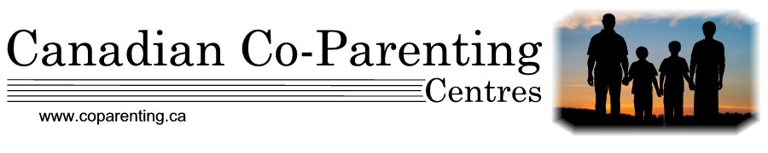
Note that if one of the existing guardians of the children has not signed this form and/or has not met with the counsellor, a release form authorizing the counsellor to contact the other guardian will be required.

